**GANPAT UNIVERSITY**

**U. V. PATEL COLLEGE OF ENGINEERING**

**B.Tech CE/IT Semester IV**

**2CEIT404: Python Programming**

**Practical-9: Python Database Connectivity**

1. **Write a python code to establish connection with MySQL and create database demo_data. Also display list of all the available database.**

**Code:**

import pymysql

con=pymysql.connect(*host*='localhost',*user*='root',*passwd*='tiger',*port*=3306)

query=("create database demo_data;")

q=("show databases;")

try:

   cursor=con.cursor()

   cursor.execute(query)

   con.commit()

   print("Database is created Successfully")

   cursor.execute(q)

   result=cursor.fetchall()

   for i in result:

     print(i)

except pymysql.DatabaseError as e:

   print("Problem is:",e)

finally:

   if cursor:

      cursor.close()

   if con:

      con.close()

**Output:**

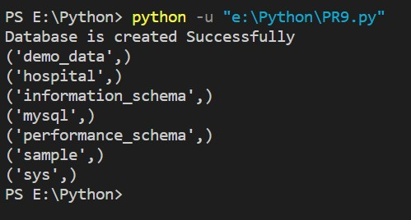

1. **Write a python code to create below specified two tables ‘hospital_details’ and ‘doctor_details’ and insert values as mentioned below.**

|  |  |  |
| --- | --- | --- |
|  | **hospital_details** |  |
| **Hospital_Id** | **Hospital_Name** | **Bed_count** |
| 1 | Janta | 200 |
| 2 | Zydus | 500 |
| 3 | Sal | 1000 |
| 4 | Stirling | 1500 |

|  |  |  |  |  |  |
| --- | --- | --- | --- | --- | --- |
|  |  | **doctor_details** | |  |  |
| **Doctor_Id** | **Doctor_Name** | **Hospital_Id** | **Specialist** | **Salary** | **Experience** |
| 101 | Karan | 1 | Pediatric | 40000 | 0 |
| 102 | Naresh | 1 | Onchologist | 80000 | 5 |
| 103 | Hardik | 2 | Surgen | 60000 | 2 |
| 104 | Vishal | 2 | Homeopathy | 50000 | 1 |
| 105 | Jay | 3 | Aayurvedic | 40000 | 0 |
| 106 | Deep | 3 | Physeotherapist | 70000 | 4 |
| 107 | Divyesh | 4 | Pediatric | 55000 | 3 |
| 108 | Arjun | 4 | Scin | 55000 | 3 |

**Code:**

import pymysql

con=pymysql.connect(*host*='localhost',*user*='root',*passwd*='tiger',*port*=3306,*database*='demo_data')

query=("create table hospital_details(Hospital_Id int,Hospital_Name varchar(30),Bed_Count int);")

q=("create table doctor_details(Doctor_Id int,Doctor_Name varchar(30),Hospital_Id int,Specialist varchar(30),Salary int,Experience int);")

try:

    cursor=con.cursor()

    cursor.execute(query)

    print("Created hospital_details Table")

    cursor.execute(q)

    print("Created doctor_details Table")

    con.commit()

except pymysql.DatabaseError as e:

                print("Problem is:",e)

finally:

     if cursor:

        cursor.close()

        if con:

         con.close()

import pymysql

con=pymysql.connect(*host*='localhost',*user*='root',*passwd*='tiger',*port*=3306,*database*='demo_data')

query=("insert into hospital_details values(1,'Janta',200),(2,'Zydus',500),(3,'Sal',1000),(4,'Stirling',1500);") q=("insert into doctor_details values(101,'Karan',1,'Pediatric',40000,0),(102,'Naresh',1,'Onchologist',80000,5) ,(103,'Hardik',2,'Surgen',60000,2),(104,'Vishal',2,'Homeopathy',50000,1),(105,'J ay',3,'Aayurvedic',40000,0),(106,'Deep',3,'Physeotherapist',70000,4),(107,'Divye sh',4,'Pediatric',55000,3),(108,'Arjun',4,'Scin',55000,3);") try:

    cursor=con.cursor()

    cursor.execute(query)

    con.commit()

    print("Inserted Values in hospital_details")

    cursor.execute(q)

    con.commit()

    print("Inserted Values in doctor_details")

except pymysql.DatabaseError as e:

                print("Problem is:",e)

finally:

    if cursor:

        cursor.close()

    if con:

        con.close()

**Output:**

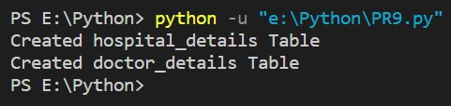

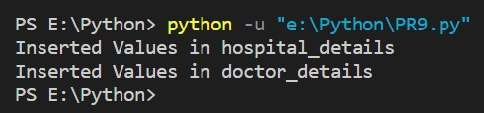

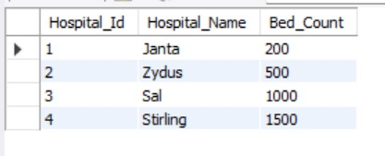

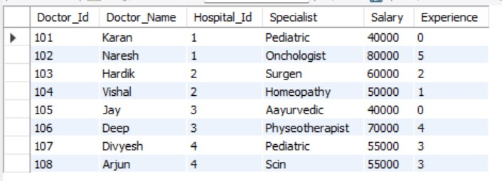

1. **Write a python code to retrieve all the details of doctors.**

**Code:**

from unittest import result

import pymysql

con=pymysql.connect(*host*='localhost',*user*='root',*passwd*='tiger',*port*=3306,*database*='demo_data')

query=("select * from doctor_details;" )

try:

    cursor=con.cursor()

    cursor.execute(query)

    result=cursor.fetchall()

    for i in result:

        print(i)

except pymysql.DatabaseError as e:

                print("Problem is:",e)

finally:

    if cursor:

        cursor.close()

    if con:

        con.close()

**Output:**

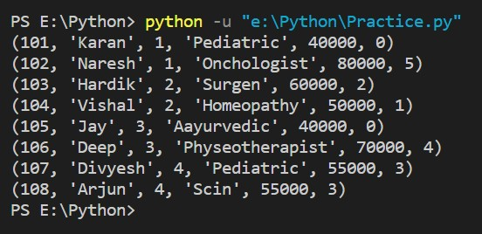

1. **Write a python code to retrieve all the doctors who are in Janta hospital.**

**Code:**

import pymysql

con=pymysql.connect(*host*='localhost',*user*='root',*passwd*='tiger',*port*=3306,*database*='demo_data')

query=("select d.* from doctor_details d, hospital_details h where h.Hospital_id=d.Hospital_id and h.Hospital_name='Janta';")

try:

    cursor=con.cursor()

    cursor.execute(query)

    result=cursor.fetchall()

    for i in result:

        print(i)

except pymysql.DatabaseError as e:

                print("Problem is:",e)

finally:

     if cursor:

        cursor.close()

     if con:

        con.close()

**Output:**

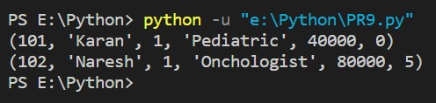

1. **Write a python code to update experience of doctors.**

**Code:**

import pymysql

con=pymysql.connect(*host*='localhost',*user*='root',*passwd*='tiger',*port*=3306,*database*='demo_data')

query=("update doctor_details set Experience='5' where Doctor_Id='101';")

try:

    cursor=con.cursor()

    cursor.execute(query)

    con.commit()

    print("Updated Successfully")

except pymysql.DatabaseError as e:

                print("Problem is:",e)

finally:

    if cursor:

        cursor.close()

    if con:

        con.close()

**Output:**

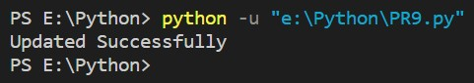

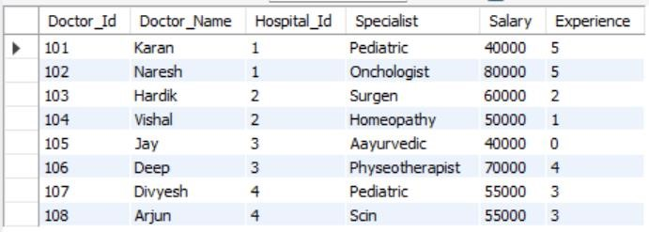

1. **Write a python code to drop table ‘hospital_details’.**

**Code:**

import pymysql

con=pymysql.connect(*host*='localhost',*user*='root',*passwd*='tiger',*port*=3306,*database*='demo_data')

query=("drop table hospital_details;")

try:

    cursor=con.cursor()

    cursor.execute(query)

    con.commit()

    print("Table is Drop")

except pymysql.DatabaseError as e:

                print("Problem is:",e)

finally:

     if cursor:

        cursor.close()

     if con:

        con.close()

**Output:**

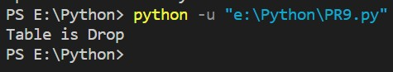



1. **Write a python code to create in memory database and table using sqlite database engine.**

**Code:**

import sqlite3

con=sqlite3.connect("memory.db")

create_table="create table memory(user_name varchar(150) not null);"

insert_record="insert into memory values('Keval Vasoya'),('Jainam Modi'),('Jaydip Patel');"

result="select * from memory;"

try:

        cursor=con.cursor()

        cursor.execute(create_table)

        print("memory Tabel is Created")

        cursor.execute(insert_record)

        print("Record Inserted")

        con.commit()

        cursor.execute(result)

        ans=cursor.fetchall()

        for i in ans:

            print(i)

except Exception as ex:

    print(ex)

finally:

     if cursor:

            cursor.close()

     if con:

            con.close()

**Output:**

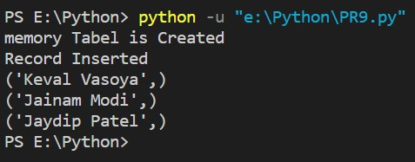

1. **Establish connection with sqlite database engine and create above tables into database demo. Show demonstration of execute script to execute multiple queries at a time.**

**Code:**

create table hospital_details (Hospital_Id *int* NOT NULL primary key,  Hospital_Name varchar(100) not null, Bed_Count bigint(20));

create table doctor_details (Doctor_Id *int* not null primary key, Doctor_Name  varchar(100), Hospital_Id *int*, Specialite varchar(100), Salary *float*, Experience  *int*);

insert into hospital_details

values(1,'Janta',200),(2,'Zydus',500),(3,'Sal',1000),(4,'Stirling',1500);

insert into doctor_details values(101,'Karan',1,'Pediatric',40000,0),

(102,'Naresh',1,'Onchologist',80000,5),

(103,'Hardik',2,'Surgen',60000,2),

(104,'Vishal',2,'Homeopathy',50000,1),

(105,'Jay',3,'Aayurvedic',40000,0),

(106,'Deep',3,'Physeotherapist',70000,4),

(107,'Divyesh',4,'Pediatric',55000,3),

(108,'Arjun',4,'Scin',55000,3);

import sqlite3

con=sqlite3.connect("demo_data")

f=open('P9.sql','r')

query=f.read()

try:

        cursor=con.cursor()

        cursor.executescript(query)

        con.commit()

        print("hospital_details tabel is Created in Database demo")

        print("doctor_details tabel is Created in Database demo")

        print("hospital_details Record Inserted")

        print("doctor_details Record Inserted")

except Exception as ex:

        print(ex)

finally:

        f.close()

if cursor:

            cursor.close()

if con:

            con.close()

**Output:**

